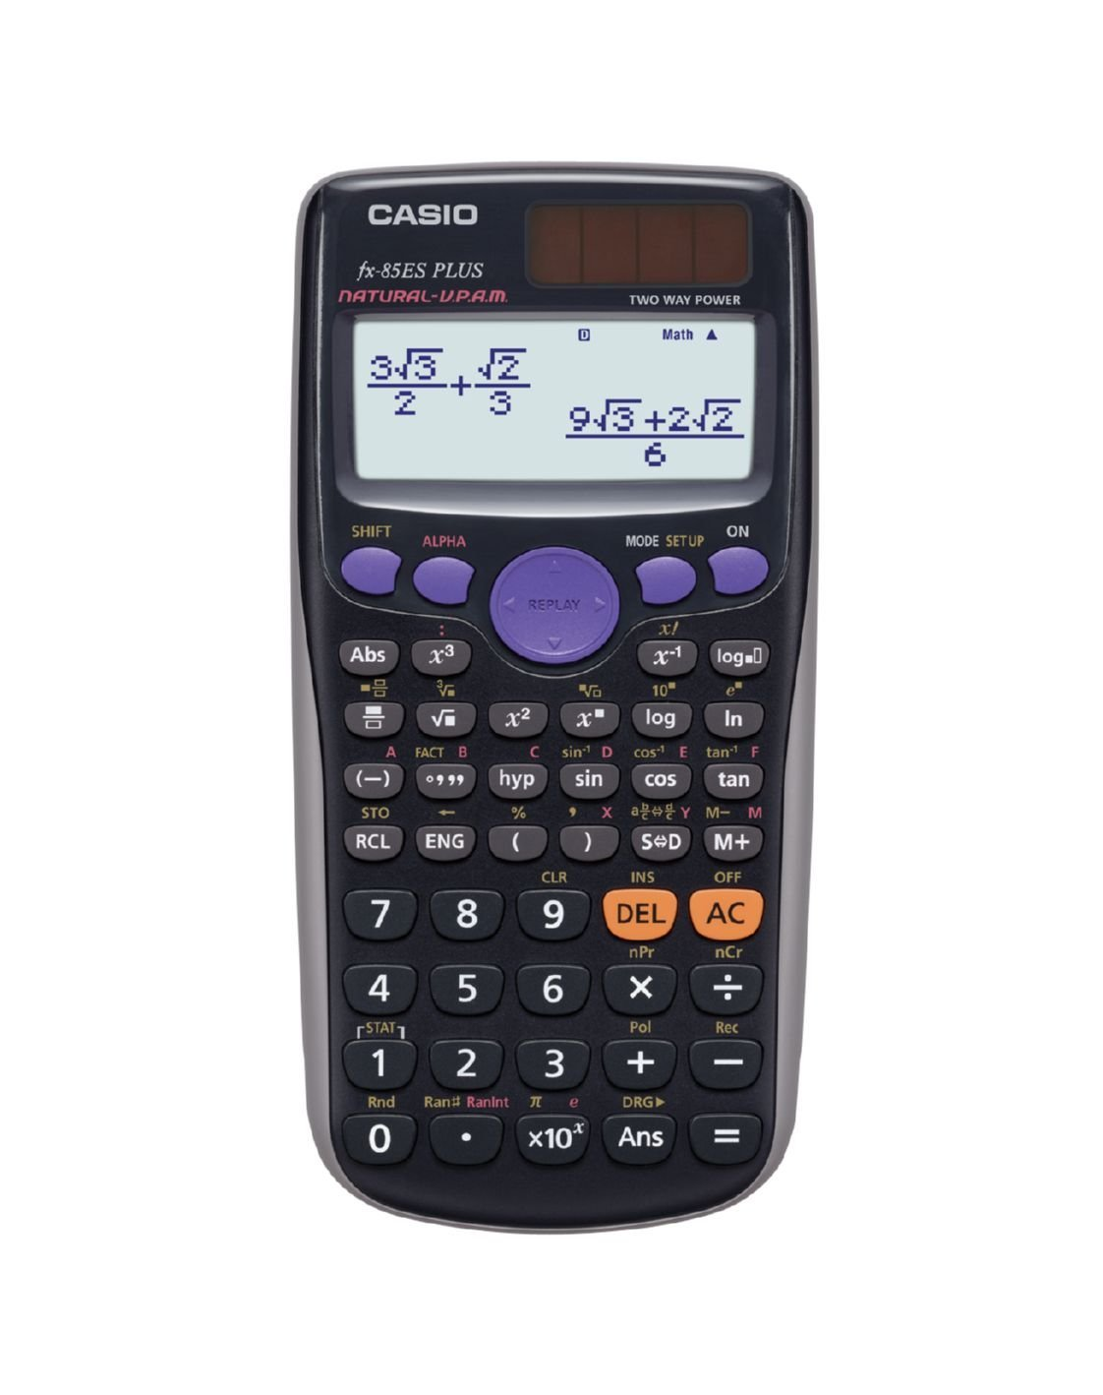

Creating a table of values

Write a number as a product of prime factors

Quadratic formula hack

Find the mean from a frequency table

Check solution to equation

Verify I have correctly manipulated an algebraic expression