Calculator hacks

1. Trial and improvement

The equation  has a solution between 2 and 3.

Use a trial and improvement method to find this solution.

Give your answer correct to 1 decimal place.

You must show **all** your working.

2. Manipulating expressions

(a) Expand and simplify 

(b) Expand and simplify 

(c) Factorise completely 

3. Product of prime factors

Write 120 as a product of primes

4. Check solutions to equations

Solve 

5. Quadratic formula

Solve giving your answer to 3sf

6. Mean from a frequency table

Lauren asks 40 people how many minutes they get to get to work.

The table shows her results. Work out the mean time.

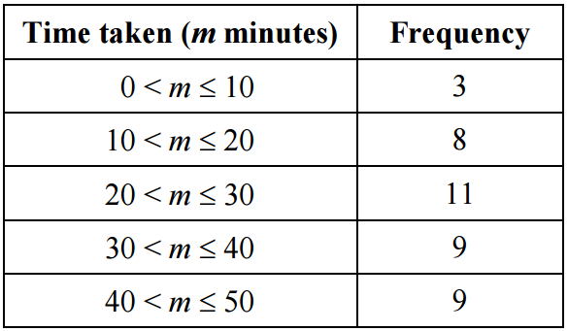

7. Drawing graphs

Complete the table of values for 

