S1 Estimation Challenge

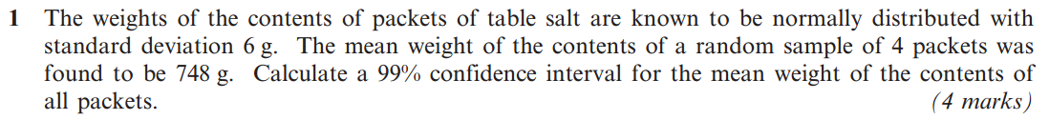**Challenge 1**

Emerald
      Juan.png

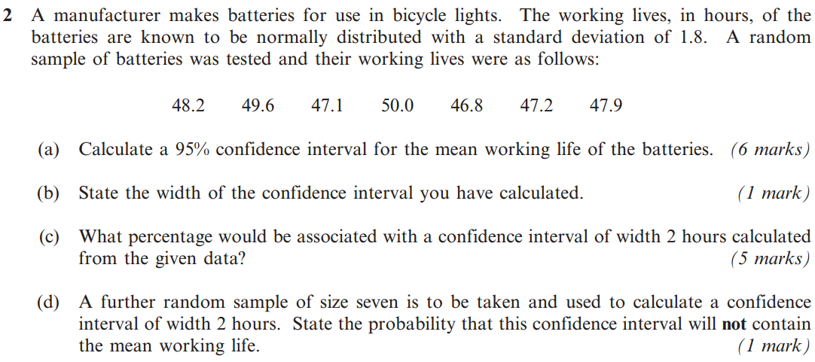**Challenge 2**

XY
      Korrina.png

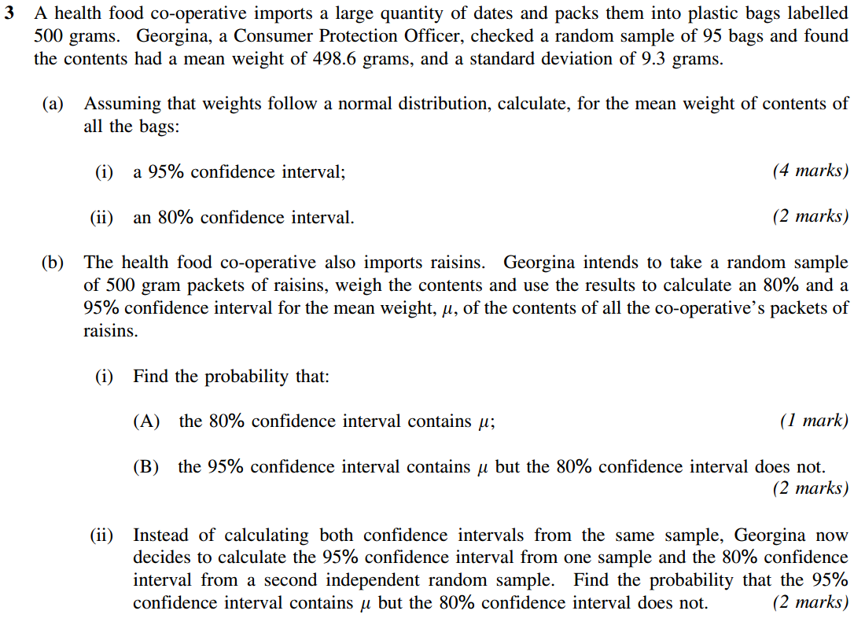**Challenge 3**



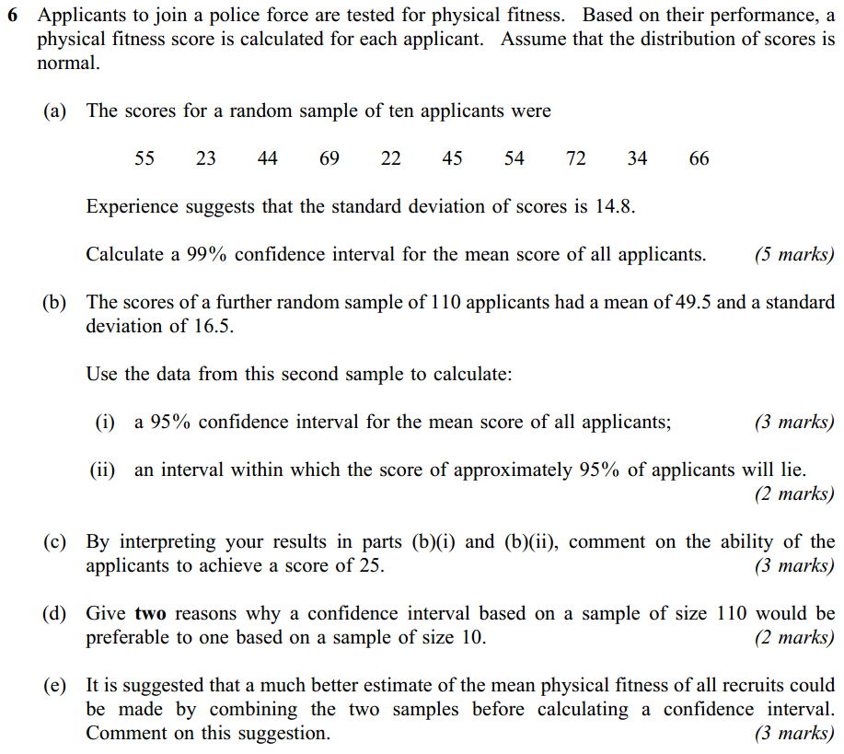**Final Challenge**

Diamond
      Pearl Volkner.png