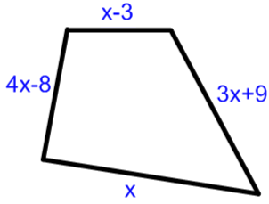  The perimeter is 34cm. Work out the value of x.  Bradley & Oleta | Jowita has some sweets.  Jasmine has 7 more than Jowita.  Frederica has 4 times as many as Jasmine.  Sukhpal has 20 less than Jasmine.  Bradley has twice as many as Jowita.  There are 148 sweets in total.  How many sweets does each person have?  Jowita & Jasmine | 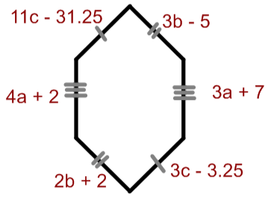  Find the perimeter.  Kian & Sukhpal
Rubayya has 6 brain fizzes more than Destiny.  Mr Ladak has twice as many brain fizzes as Destiny.  Bradley has 3 times as many brain fizzes as Rubayya.  How many does each person have if there are 87 altogether?  Hassan | 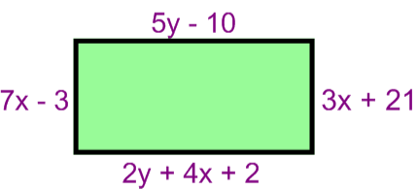  Work out the perimeter and the area of the rectangle  Shona & Frederica | Steve has 3 doughnuts more than Clint.  Bruce has 4 times more doughnuts than Clint.  Tony has 9 times more doughnuts than Steve.  How many doughnuts does each person have if there are 330 altogether?  Lucy & Hannah
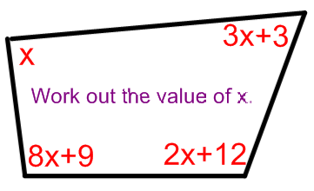  Jowita & Jasmine | Shona has 4 more sweets than David.  David has 2 more sweets than Bradley.  Frederica has as many sweets as David and Bradley combined.  There are 35 sweets altogether.  How many sweets do they each have?  Chris & Saif | 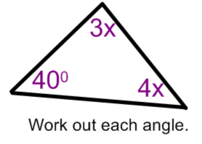  Hifsah & Sadera

